* Open Git bash at path : …\Lab1-Freelancer\freelancer

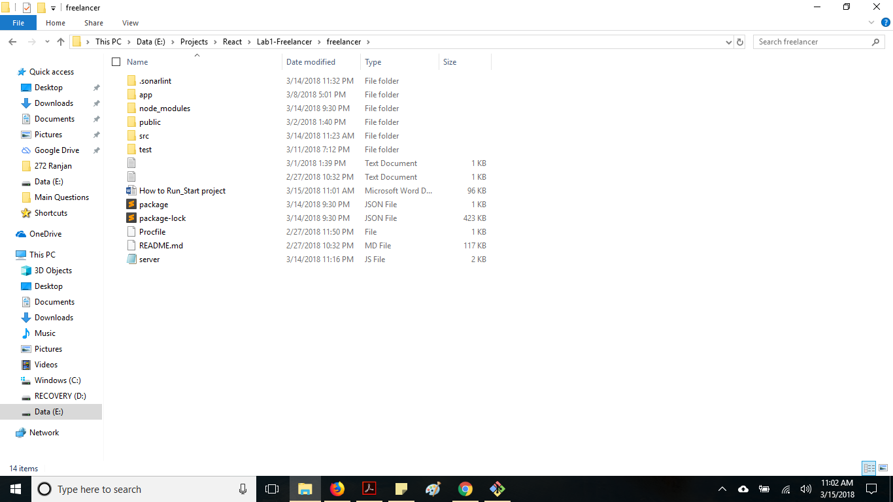

* Install all dependencies as mentioned in package.json
  + npm install
* Run below command:
  + npm run start-dev : This will start ReactJS server on 3000 port and NodeJS server will start at 3001 port.